Horizontal Laminar Flow

Clean Bench Product Technical Manual
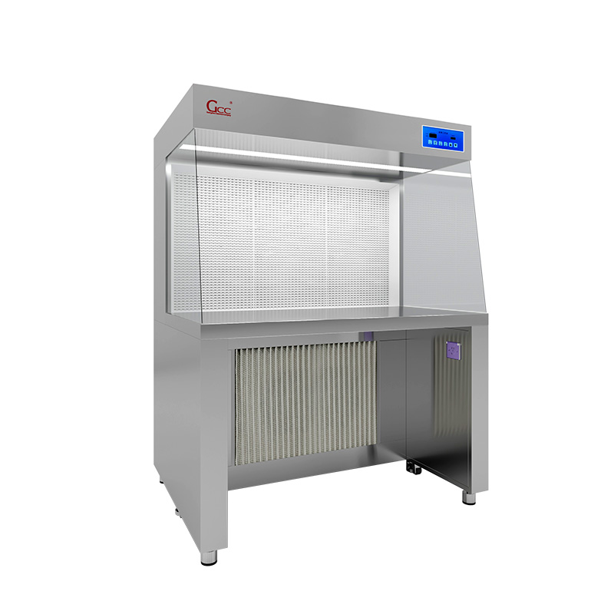

Guangzhou Cleanroom Construction Co., Ltd.

Key Features:
· 304 Stainless Steel Construction
Manufactured with 304 stainless steel for the workbench structure and countertop, providing a durable, corrosion-resistant and easy-to-clean working surface.
· Compact Enclosed Working Area
The internal working area measures 930 × 600 × 600 mm, providing a controlled workspace for laboratory and cleanroom operations.
· H13 HEPA Filtration
Equipped with an H13 high-efficiency filter to provide filtered airflow within the working area.
· Multi-Stage Air Filtration
Includes both a primary filter and H13 high-efficiency filter to support effective air filtration and protect the main filtration system.
· Integrated Lighting System
Includes one LED panel light for workspace illumination and one sterilization lamp for routine sterilization requirements.
· Tempered Glass Side Panels
Both sides are fitted with tempered glass panels, providing visibility of the working area while maintaining an enclosed configuration.
· Built-In Electrical Outlets
Equipped with two 220V/10A three-pin electrical outlets for connecting laboratory equipment and accessories.
· Powerful Fan System
Fitted with a 220V, 285W fan to provide airflow for the filtration system.
· Mobile Design
Four universal casters allow convenient movement and positioning of the workbench.
· Standard Configuration
Unless otherwise specified, the manufacturing process and configuration are supplied according to our standard production specifications.

Technical Parameters:
Item | Specification
Product Type | Stainless Steel Clean Workbench
Material | 304 Stainless Steel
Overall Dimensions | 1000 × 900 × 1500 mm
Internal Working Area | 930 × 600 × 600 mm
HEPA Filter | H13 High-Efficiency Filter
Primary Filter | Included
Fan | 220V, 285W
LED Panel Light | 1 pc
Sterilization Lamp | 1 pc
Side Panels | Tempered Glass, Both Sides
Airflow Component | Air Diffuser
Electrical Outlets | 2 × 220V/10A Three-Pin Sockets
Casters | 4 Universal Casters
Countertop | 304 Stainless Steel
Power Cable | Power Outlet Cable Included
Control Panel | Included

Applications:
This 304 stainless steel clean workbench is suitable for controlled working environments where filtered airflow, easy cleaning and enclosed operation are required, including:
- Pharmaceutical laboratories
- Medical and healthcare facilities
- Biotechnology laboratories
- Microbiology laboratories
- Medical device production
- Electronics and precision component assembly
- Cleanroom production areas
- Laboratory sample preparation
- Research and development laboratories

Schematic Diagram:

